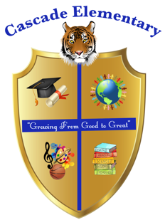

Cascade Elementary Website
Weekly Grade Level News Blast

Week of: Monday, April 13, 2020

Grade Level: 3rd

Standards of the Week:
Language Arts - L1a - Explain the function of adjectives in general and their functions in particular sentences.

Reading – RL9 - Compare and contrast the themes, settings, and plots of stories written by the same author about the same or similar characters (e.g., in books from a series).

Math – MD2 - Measure and estimate liquid volumes and masses of objects using standard units of grams (g), kilograms (kg), and liters (l).

Science – P1 - Obtain, evaluate, and communicate information about the ways heat energy is transferred and measured.
Social Studies – CG2 - Explain the importance of Americans sharing certain central democratic beliefs and principles, both personal and civic.

Additional Information for Parents and Students:
- Sign up for ClassDojo
- Check the 3rd Grade WeatherWise GoogleClassroom daily
- Daily Zoom meeting with teachers @ 10:00 am
- Email teachers
  - Ms. Cook – tsbell@atlanta.k12.ga.us
  - Ms. Diggins - Courtni.Diggins@atlanta.k12.ga.us
  - Mr. Mills - wmills@atlanta.k12.ga.us
  - Ms. Peete - nopeete@atlanta.k12.ga.us

